MaryBeth Steigerwald

(773) 576-1575

Maureen Bryers | Patia Colovos | Linda Ori
(773) | (773) | (312)
763-2394 | 505-3450 | 919-9413
Grace Jops | Angela Slaiwa | Daniela Nieves
(312) | (773) | (773)
315-1710 | 771-6608 | 680-7485
Kerry Bergl | Kelly | Hope Alkass
(630) | Fahrenbach | (773)
605-0947 | (773) 552-6654 | 517-9895
Alma Ocampo- | Stacy | Jaclyn Krysinski
Nunez | Nikolopoulos | (847)
(773) 507-1980 | (847) 226-6366 | 791-3635
Lia Megremis | Debra Boone - | Katie Coombs
(773) | Monroe | (314)
853-0483 | (773) 450-8365 | 313-0367
Carol | Liz Welenc | Jen Scott
Feichtinger | (847) | (773)
(773) 736-6709 | 220-1915 | 383-1030
Beaubien Phone Tree
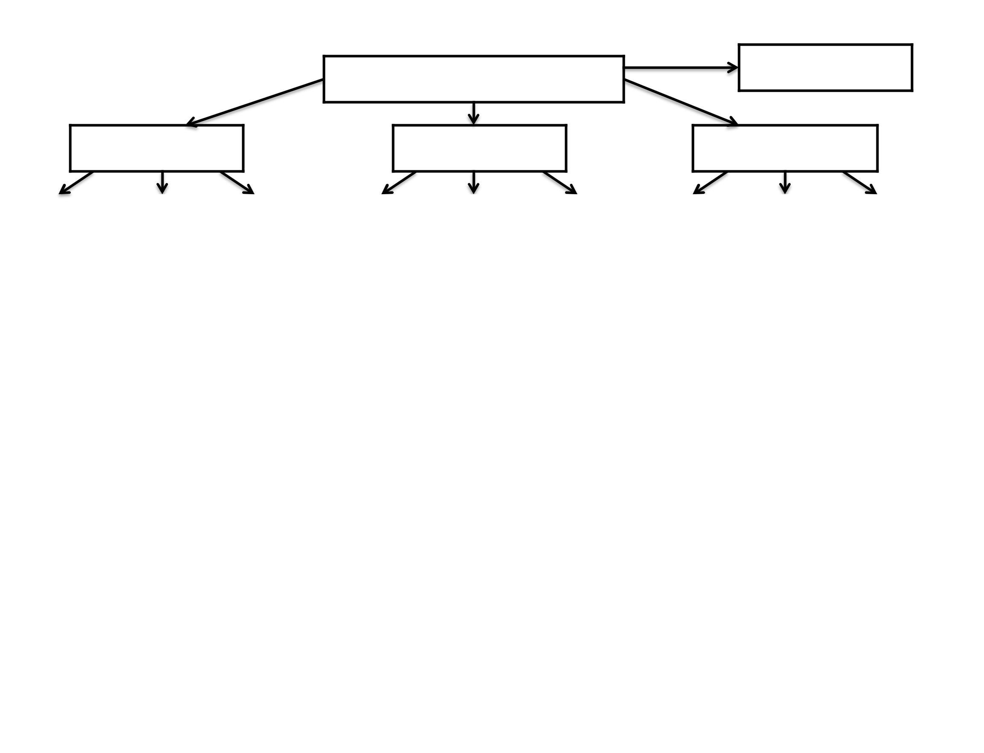

Michelle Ludford

(773) 510-5897

Erica Loftus

(773) 575-7029

Maria Vlahos | Georgia |  | Sandra Olson
(312) | Lambropoulos |  | (773)
404-0837 | (773) 507-3853 |  | 314-6616
Tammy | Paula Wyatt |  | Karen Meeters
Lymperopoulos | (773) |  | (773)
(224) 628-5237 | 562-1234 |  | 491-5597
Laura Maniaci | Gail | Bassett | Kerry | Hurley
(773) |  | (773) |  | (773)
282-0106 | 209-7595 |  | 726-3790
Brenda Calvillo | Debbie Sanchez |  | Chrissy Walsh
(708) | (773) |  | (630)
927-7157 | 544-1121 |  | 300-4126
Lucy Hannah | Margaret |  | Jackie Hernandez
(513) | Ornowska |  | (872) 800-1466
226-7929 | (773) 809-1278 |  | (773) 276-4691
Natalie Davis | William |  | Victoria Matej
(734) | Gonzalez |  | (847)
546-0321 | (773) 414-4588 |  | 508-9471

Nick Kotis

See page 2

Debbie Solka

(847) 687-7605

Vicki Martinski | Stella Choi | Dawn Wiley
(630) 516-0202 | (773) | (773)
(773) 612-7786 | 396-1064 | 255-6707
Nancy Fritz | Sharon O’Connell | Renee Frytz
(773) | (773) 623-7614 | (847)
330-7624 | (773) 774-2324 | 337-0619
Christine Barrett | Kim Cutro | Celena Santana
(312) | (773) | (773)
919-9402 | 370-2559 | 387-7872
Kristy Combs | Nora Nagle | MaryEllen Sarria
(773) | (708) | (317)
507-5679 | 641-1122 | 989-3171
Bill Burns | Lorraine Lynch | Therese Wendt
(773) | (773) | (262)
615-6639 | 216-5416 | 374-0195
Kim Sineni | Ellie Santana | Sue Manchester
(773) | (312) | (773)
612-7783 | 720-4604 | 835-3433
Sue Sebesta | Shelley Davis | Jim Carr
(312) | (773) | (773)
914-9124 | 330-8458 | 203-5858

p. 1 of 2

Paula Barnhart

(773) 430-3388

Laura Arteaga |  |  | Yvonne | Marsha Koumbis
(773) |  |  | Smilovitz | (773)
620-9109 |  | (773) 410-9076 |  | 812-0153
Betty Sepanik |  |  | Margaret | Georgia Demertzis
(312) |  |  | Shannon | (224)
404-5985 |  | (773) 777-9718 |  | 639-8887
Janet Kuszynski |  | Alma Medina |  |  | Maria Latona
(312) |  | (708) |  | (773)
608-6562 |  | 699-6017 |  | 589-9781
Muna Saleh |  | Nelida Alanis |  |  | Val Williams
(773) |  | (773) |  | (773)
507-5190 |  | 600-9107 |  | 558-4685
Matt Resendiz |  | Anita Yousif |  |  | Ellie Santana
(773) |  | (773) |  | (312)
822-4499 |  | 617-2650 |  | 720-4604
 |  | Janine Devine |  | MaryAnn Ehrlich
 |  | (773) |  | (773)
 |  | 251-2723 |  | 827-9989
Beaubien Phone Tree
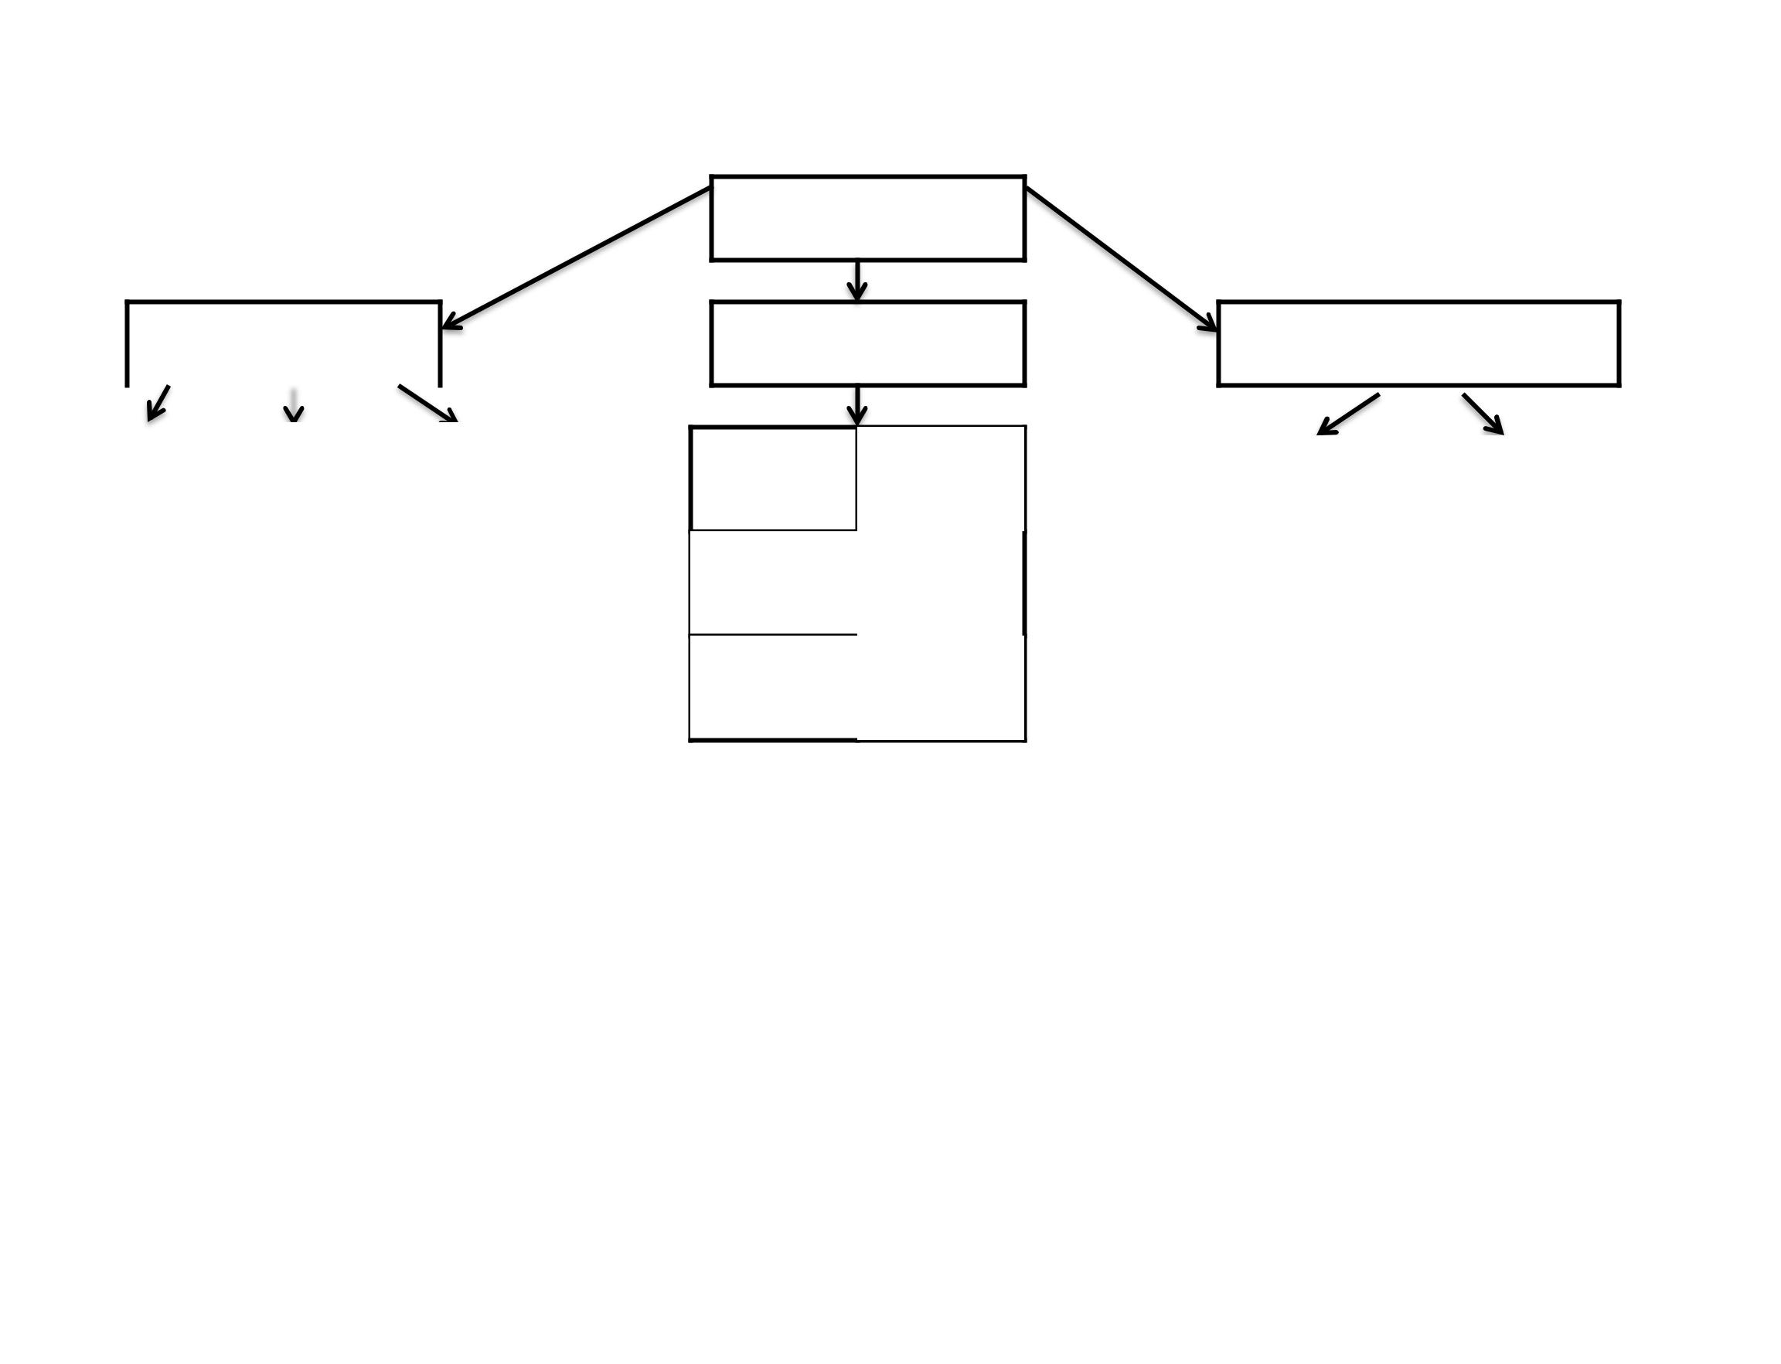

Nick Kotis

(773) 817-6070

Kevin Cooke

(773) 220-4697

Odillio Mercado | Guissel Simental
 | (773)
 | 273-7121

Eugenia

Chrisanthou
(773) 283-0854

Lily Sidereas

(773)
556-3382

Kim Beschorner

(847) 854-5329 or (847) 477-8085

Tere Meraz | Gloria Thayer
(773) | (708)
981-0962 | 204-3905
Liana Lipa | Preya Sleeba
(773) | (312)
870-6602 | 965-9259
Katie Yoon | Ari Cosey
(847) | (971)
769-5995 | 226-0773
Craig Miller
(847)
674-4505

p. 2 of 2

