TransAct Phone Tree |  |  |  |  |  |  |  |  |  |  | COMMON MENU
GREETING
 |  |  |  |  |  |  |  |  | 9 |  |  | Repeat Menu
1 |  | Account Information |  | Account Access |  |  |  |  |  | * |  | Previous Menu
4 |  | Report a Lost/Stolen Card |  | Validate Caller |  |  |  |  |  | 8 |  | End Call
 |  |  |  |  |  |  |  |  |  | 0 |  | Call Center Representative


MAIN MENU
1 |  |  | TRANSACTIONS |  |  |  | 2 |  | INQUIRIES |  |  | 3 |  |  | CHANGE PASSWORD
 |  |  | TRANSACTION MENU |  |  |  |  |  | INQUIRY MENU |  |  |  |  |  | Change Pin
 |  |  | 1 | Transfer Funds |  |  |  |  | 1 | Balance on Accounts
 |  |  | 2 | Withdraw by Check |  |  |  |  | 2 | Specific Account Info
 |  |  | 3 | Stop a Check
 |  |  |  |  |  |  |  |  | ACCOUNT INQUIRY
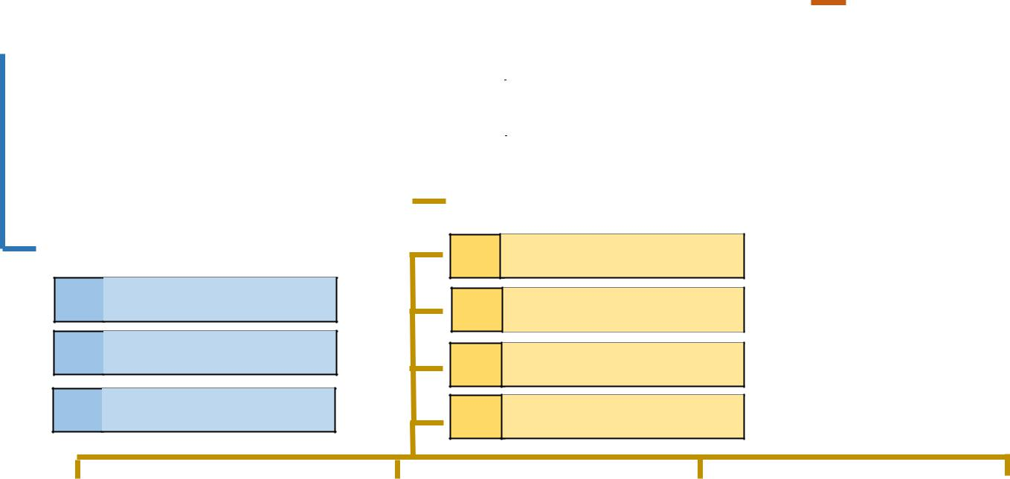

TRANSFER MENU

- Draft/Money Markets

- Share Account

3 Loan Account

- Drafts/Money Markets

- Share Accounts

- Loan Accounts

- Share Certificates

 |  | CHECKING INQUIRY |  |  |  |  |  |  | SAVINGS INQUIRY |  |  |  |  | LOAN INQUIRY |  |  |  |  |  | Share Certificates
 | 1 |  | Recent Transactions |  |  |  | 1 |  |  |  | Recent Transactions |  | 1 |  | Recent Transactions |  |  |  | 1 |  | Recent Transactions
 | 2 |  | Debit Transactions |  |  |  | 2 |  |  |  | Specific Transactions |  | 2 |  | Last Payment |  |  |  | 2 |  | Specific Transactions
 | 3 |  | Specific Transactions |  |  |  | 3 |  |  |  | Dividends |  | 3 |  | Next Payment |  |  |  | 3 |  | Dividends
 | 4 |  | Dividends |  |  |  | 4 |  |  |  | Balance |  | 4 |  | Payoff Amount |  |  |  | 4 |  | Balance
 | 5 |  | Balance |  |  |  |  |  |  |  |  |  | 5 |  | Repeat Balance Info
 |  | SPECIFIC CHECKING |  |  |  |  |  |  | SPECIFIC CHECKING
 |  | TRANSACTIONS |  |  |  |  |  |  | TRANSACTIONS
 | 1 |  | Debit Transactions |  |  |  |  |  | 1 |  | Withdrawals
 | 2 |  | Withdrawals |  |  |  |  |  | 2 |  | Deposits
 | 3 |  | Deposits |  |  |  |  |  | 3 |  | ATM


- ATM
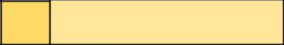

- Specific Check
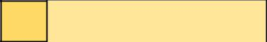

- Last 5 Checks

