PHONE TREE 2015-16
ETFO Members

School Name _________________________________________ FOS_____________

Steward
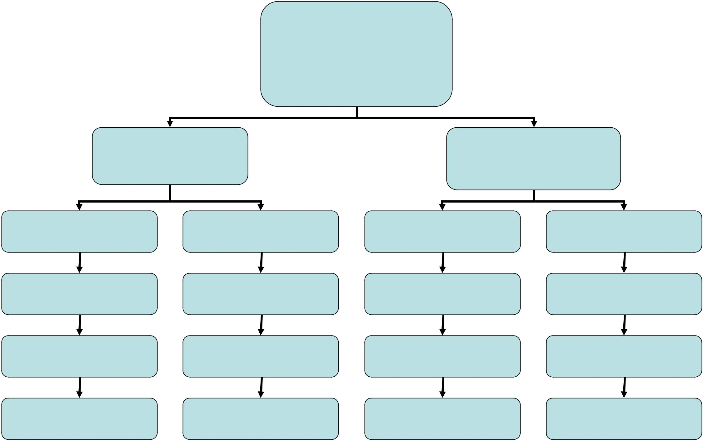

Name
Home Phone:____-____-____

Cell Phone:____-____-____

Name |  | Name
Home Phone:____-____-____ |  | Home Phone:____-____-____
Cell Phone:____-____-____ |  | Cell Phone:____-____-____
Name | Name | Name | Name
Home Phone:____-______-______ | Home Phone:____-______-______ | Home Phone:____-______-______ | Home Phone:____-______-______
Cell Phone:____-______-______ | Cell Phone:____-______-______ | Cell Phone:____-______-______ | Cell Phone:____-______-______
Name | Name | Name | Name
Home Phone:____-______-______ | Home Phone:____-______-______ | Home Phone:____-______-______ | Home Phone:____-______-______
Cell Phone:____-______-______ | Cell Phone:____-______-______ | Cell Phone:____-______-______ | Cell Phone:____-______-______
Name | Name | Name | Name
Home Phone:____-______-______ | Home Phone:____-______-______ | Home Phone:____-______-______ | Home Phone:____-______-______
Cell Phone:____-______-______ | Cell Phone:____-______-______ | Cell Phone:____-______-______ | Cell Phone:____-______-______
Name | Name | Name | Name
Home Phone:____-______-______ | Home Phone:____-______-______ | Home Phone:____-______-______ | Home Phone:____-______-______
Cell Phone:____-______-______ | Cell Phone:____-______-______ | Cell Phone:____-______-______ | Cell Phone:____-______-______

Phone Tree Instructions

The Steward (the contact at the top of the tree) starts the telephone tree phoning process. Depending on the action and the level of detail required, it may be helpful to write a brief script.

- Call your assigned contact(s).
- Ask the contact to get a paper and pencil so that they can write down specifics.
- Provide the necessary information about the event/action.
- Confirm that the contact will be making the next call on the list.

What if nobody answers?

If nobody answers, leave a message and call the next person down on the tree. This should ensure that everyone gets the information in a timely fashion.

I’m at the end of the contact list. What do I do?

Prearrange with staff at the end of the list to contact the person at the top once they receive the message. The LAST person on the phone tree should CALL THE FIRST person to ensure that the tree is completed and that the message was accurate.

