ND WIC Local/State

Calling Tree
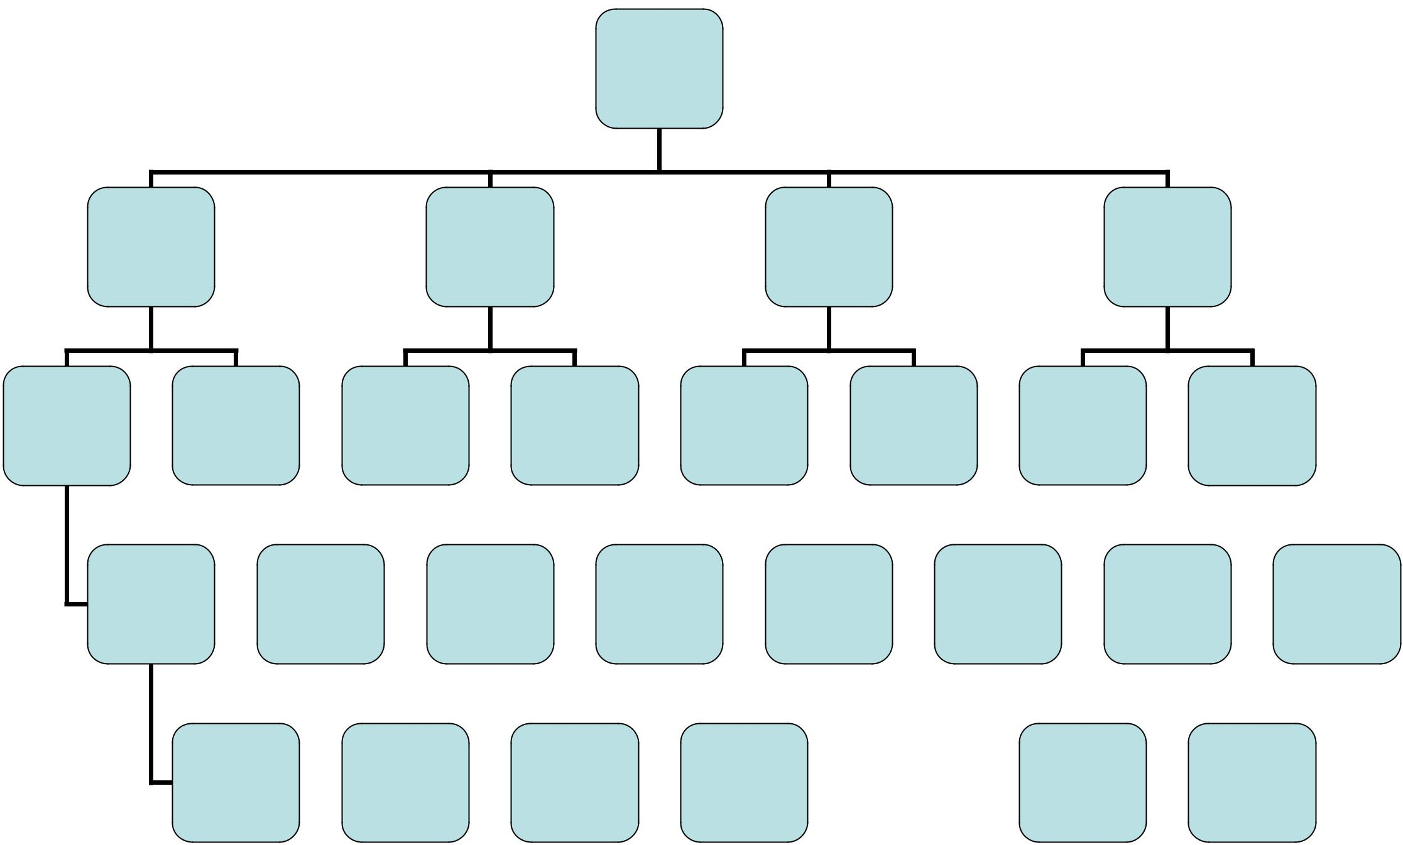

ND WIC

Directors
Calling

Tree

Kristi | Colleen | Kim | Carley
328.2496 W | 328-2496 W | 328.2496 W | 328.2496 W
426.7204 C | 222-1847 C | 214.2447 C | 426-2865 C
221.0855 H |  | 258.5104 H

Shannon | Kim V | Carolyn S. | Liz | Jim | Sheri | Jeanna | Barb
255.3397 W | 277-1455 W | 775.3667 W | 774.6401 W | 852.1376 W | 662.7043 W | 477.6436 W | 483.1942 W
471-5394 C | 412- 6494 C | 330-2263 C | 570.2857 C | 721.2982 C | 230.2812 C | 246.3514 H | 290.0369 C
 |  |  |  |  |  | 871-2548 C

JoAnn |  | Susan W |  | Betsy |  | Anita |  | Notify all |  | Jennifer |  | Beth V |  | Julie W
797.2221 W |  | 788.3800 W |  | 352.5139 W |  | 252.8130 W |  | Notify all |  | 766.4242 W |  | 845.8520 W |  | 254.4030 W
797.7072 C |  | 788.3108 C |  | 218.779.5306 |  | 320.8235 C |  | FDHU WIC |  | 550-0374 C |  | 840.3331 C |  | 605.437.2382
 | 430-1944 |  |  | Cell |  |  |  | sites |  |  |  |  |  | H

Linda |  | Danielle |  | Hollie |  | Lucy |  | Margie |  |  | Adrienne
567-6197 W |  | 642.7735 W |  | 724.3725 or |  | 288.3433 W |  | 883.4250 W |  |  | 265.4764 W
928.1081 C |  | 640.0926 C |  | 683.6140 W |  | 535.0254 C |  | or |  |  | 265.4257 H
 |  |  |  | 680.9028 C |  |  | 830.0572 |  | H

WIC Emergency Notification Protocol:

The State WIC office staff will activate the calling tree when necessary.

Staff should call their contact place of work first and then the second number listed. Cell phone numbers were provided when available. If your contact is not available, please leave a message. And if they are scheduled to call someone please call that person.
All numbers assume a 701 area code, except when noted.

It is assumed that Directors with WIC staff located at clinic locations outside of their main office, will make those calls to the staff.

Additional contact numbers (home land lines) are also listed on the ND WIC Directors land line/cell phone list.

Nutrition and Physical Activity, ND Department of Health, Toll-free Line: 800.472.2286

Mountain Plains, Food and Nutrition Service WIC Regional Office Denver: 303.844.0331

January 2016

