PPSD Statewide Customer Contact Center (Call Tree
916-372-7200
Hours of Operation 8:00 – 3:45

PPSD staff will return all voicemail messages within 2 business days

1 |  |  |  |  |  |  | 2
Statewide |  |  |  |  |  |  | Statewide
Direct |  |  |  |  |  |  |  | Civil
Deposit |  |  |  |  |  |  | Service
Program |  |  |  |  |  |  | Program
 |  |  |  | 1
 |  |  |  |  |  |  | Position
 |  |  |  |  |  |  | Control
 |  |  |  | 2
 |  |  |  |  |  |  | Personnel
 |  |  |  | 3
 |  |  |  |  |  |  | Benefits
 |  |  |  | 4
 |  |  |  |  |  |  | Payroll
 |  |  |  |  |  |  |  |  | 1
 |  |  |  |  |  |  |  |  |  |  |  |  |  |  | Premium Pay
 |  |  |  |  |  |  |  |  | 2
 |  |  |  |  |  |  |  |  |  |  |  |  |  |  | Stipulations
 |  |  |  |  |  |  |  |  | 3
 |  |  |  |  |  |  |  |  |  |  |  |  |  |  | Garnishments
 |  |  |  |  |  |  |  |  | 4
 |  |  |  |  |  |  |  |  |  |  |  |  |  |  | Voluntary
 |  |  |  |  |  |  |  |  |  |  |  |  |  |  | Deductions
 |  |  |  |  |  |  |  |  | 5
 |  |  |  |  |  |  |  |  |  |  |  |  |  |  | All Other
 |  |  |  |  |  |  |  |  |  |  |  |  |  |  | Payroll
 |  |  |  |  |  |  |  |  |  |  |  |  |  |  | Questions
 |  |  |  | 5
 |  |  |  |  |  | Retirement
 |  |  |  | 6
 |  |  |  |  |  |  | Disability
 |  |  |  |  |  |  |  | 1
 |  |  |  |  |  |  |  |  |  |  |  |  |  |  |  | IDL
 |  |  |  |  |  |  |  | 2
 |  |  |  |  |  |  |  |  |  |  |  |  |  |  | NDI/SDI/TD



3
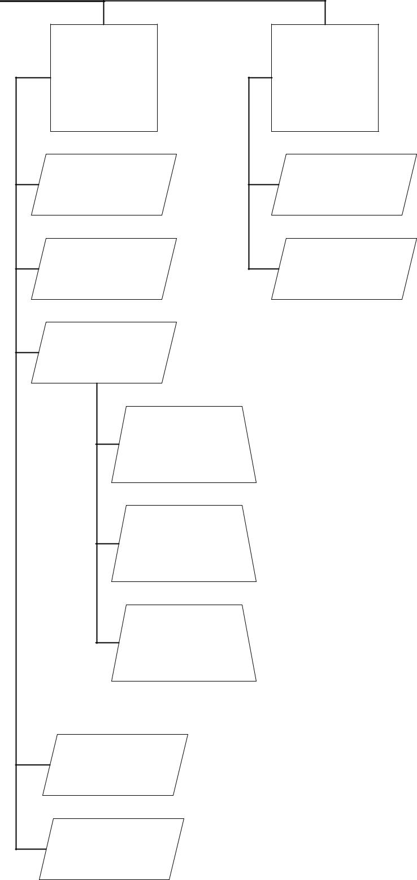
Statewide
CSU
Program

1
Personnel

2
Benefits

3
Payroll

1
Garnishments

2
Voluntary
Deductions

3
All Other
Payroll
Questions

4
Retirement

5
Disability

4
Statewide
W-2 /Tax
Support
Program

1
W-2

2
Tax Support

