 | Ch apter Phone Tree |  |  | Chapter:
 |  |  |  | La st revised:
Regional S’gan/S’ ganit: |  |  | President: |  |  | Advisor( s):
T el: |  |  | Tel: |  |  | Tel:
E -mail: |  |  | E-mail: |  |  | E-mail:

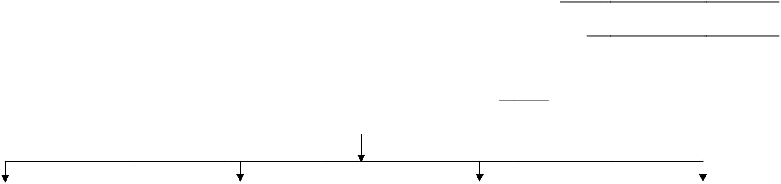

 | C | aptain 1: |  |  |  |  | Captain 2: |  |  |  |  |  | Capt | ain 3: |  |  |  |  | Captain 4:
 | T | el: |  |  |  |  | Tel: |  |  |  |  |  | Tel: |  |  |  |  |  | Tel:
 | E- | mail: |  |  |  |  | E-mail: |  |  |  |  |  | E-m | ail: |  |  |  |  | E-mail:
Reminder: If there are any problems or changes (e.g. Wrong numbers, someone wants to be removed from the list, etc.), please inform the Regional Office right away and the database will be adjusted accordingly.

Mazkirim: Be sure to add newly involved prospects to your Phone Tree regularly, and send an updated copy

to your Phone Tree Captains as well as to the Regional S’gan/S’ganit, Shia Cooperman-Green or Maya Feldberg.

Tips for your phone calls…

- Be enthusiastic and excited for the programs you’re promoting!

- Be sure to explain the programs/events, and provide the date, time and location of each.

- You can offer your phone number if people want to get back to you later to get more details about the program.

- If leaving a message, include the program details as well as your name and phone number so people can call you back. (Calling back the next day wouldn’t be a bad idea either!)

- If possible, be personal with your call. (E.g. If you remember the person from a previous program, say something like “I was at (program), maybe you remember me? It would be great to see you again!” or “Did you have fun at (program)?”

- Write down all the details of the programs so you don’t forget to mention anything during your call. A script may also help you… (See sample script to the right! ☺)

Sample Script for Calling Non-Members…

Perspective: Hello?

You: Hi, this is _______ from BBYO. Is this/may I speak to

_______?

Perspective: Yes this is ______.

You: How are you doing?

Perspective: I’m good thanks, and you?

You: I’m good, thank you! I don’t know if you’ve recently received mail or email from us but on (date) at (time) we’re having a really fun program! We’re going to (explain what the program is). It’s going to be really great! Are you interested in coming?

Perspective: I’m not sure….

You: It’s only going to cost (amount)/ It’s free! And it’s going to be a lot of fun! I’ll be there and it’d be really cool if you came! Perspective: Well I have to check with my parents, but maybe I can make it…

You: Okay, well I really hope to see you there! Bring a friend if you would like! If you want any more information, feel free to call me! Do you want my number?

Perspective: Sure.

You: My number is (phone number). Give me a call! Hope to see you there!

