Telephone Tree for Group Communication
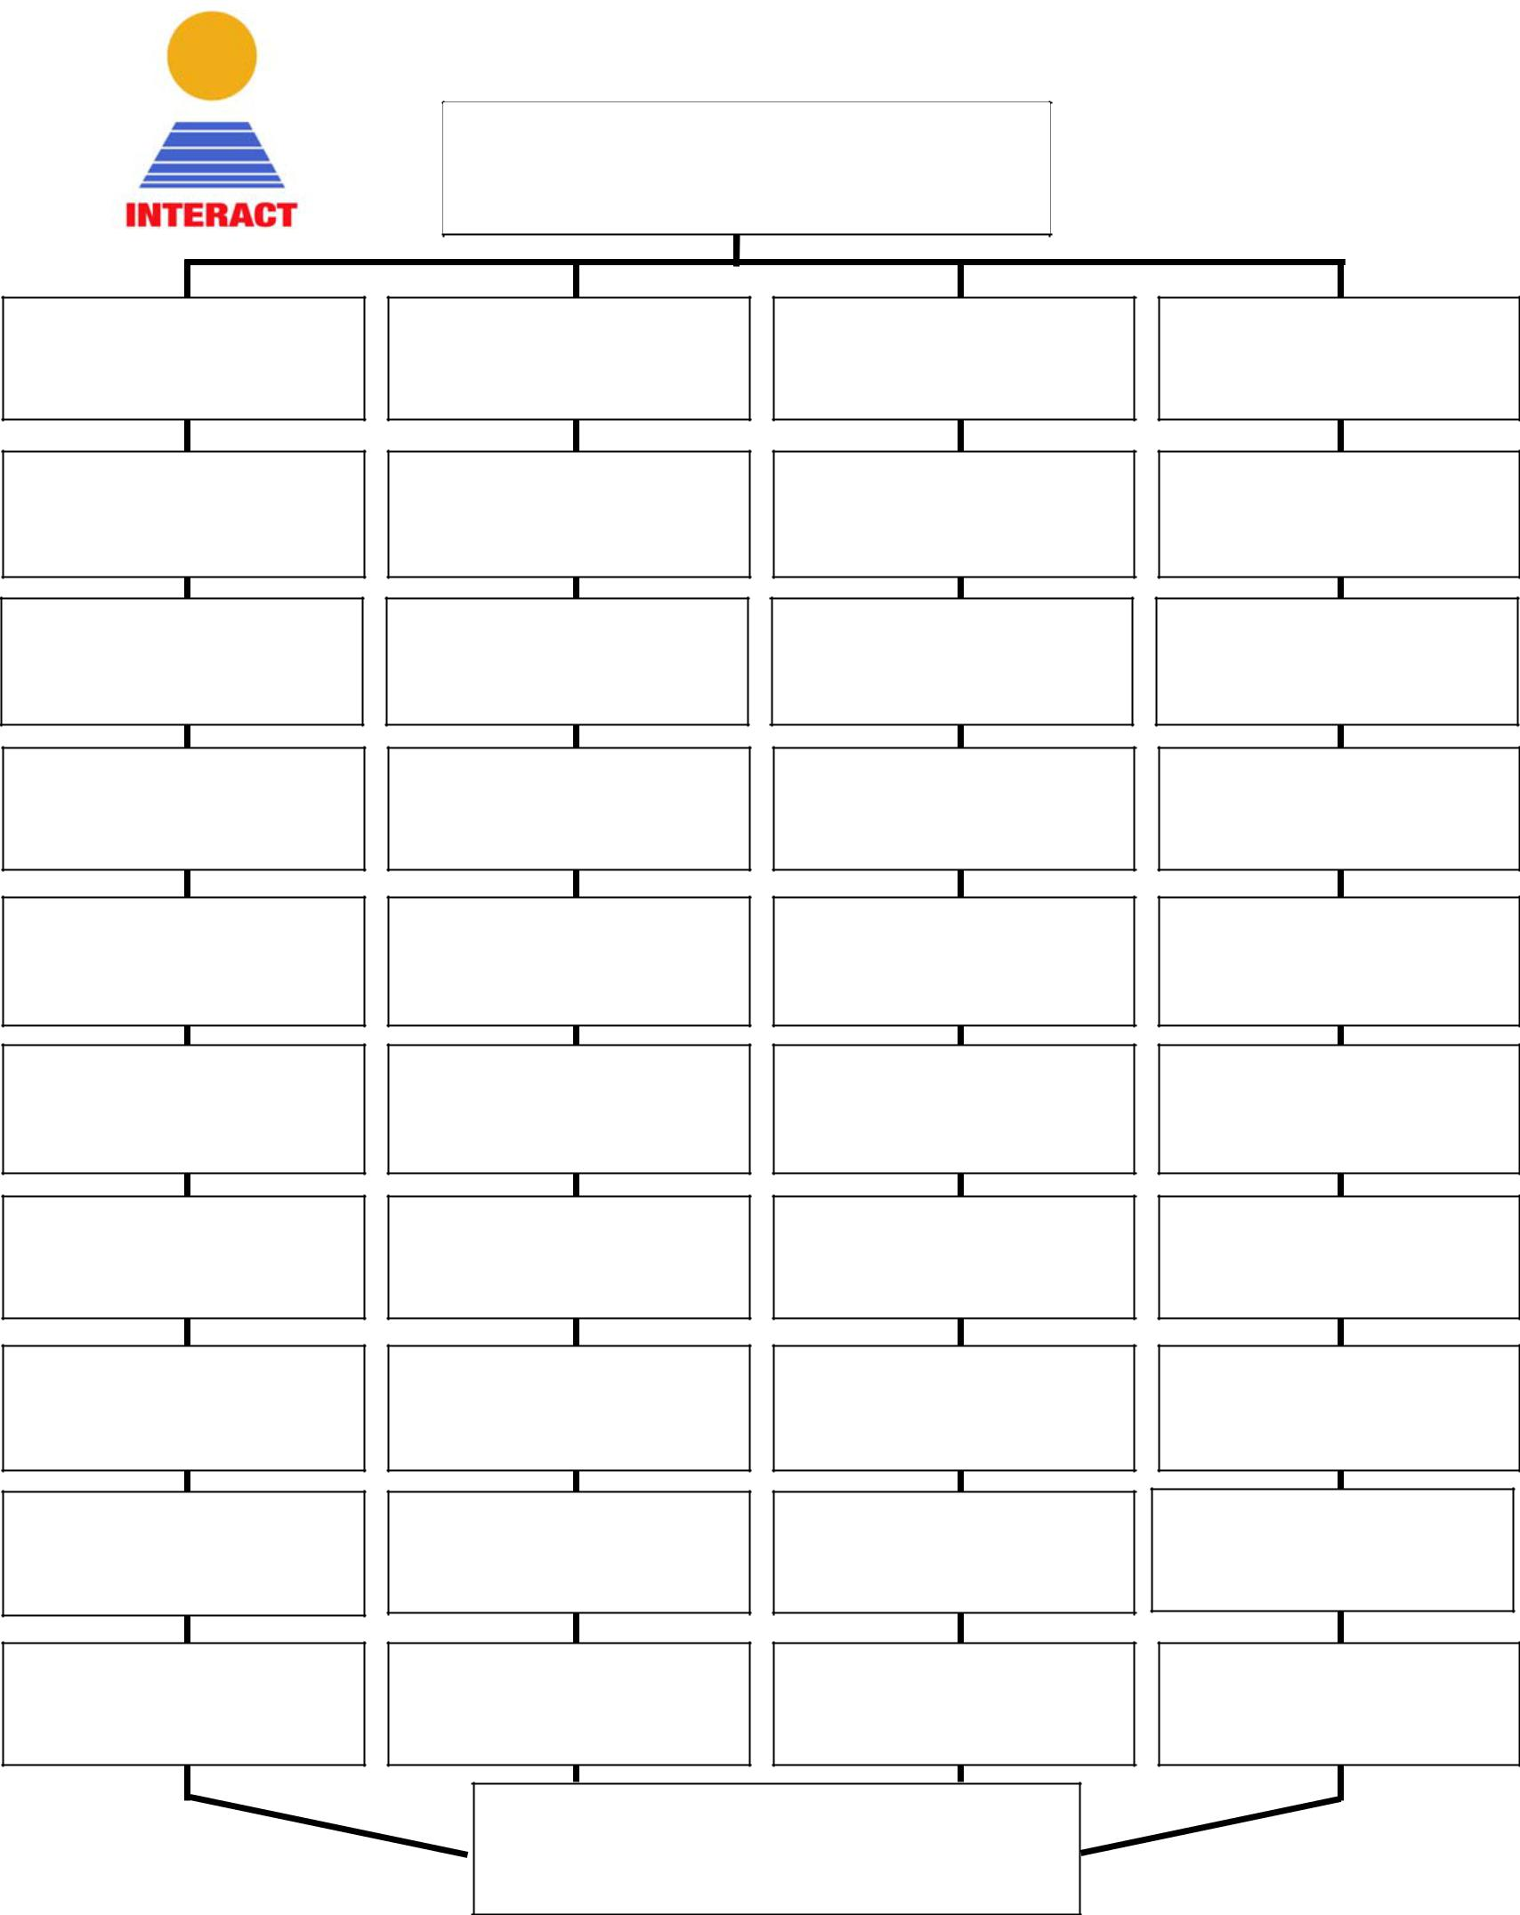

John Doe
Name:

Phone:
Cell:

Name:
Jane Doe
Jane Doe
Jane Doe
Jane Doe

Phone:
Cell:
Jane Doe
Jane Doe
Name:

Phone:
Cell:

Name:

Phone:
Cell:

Name:

Phone:
Cell:

Name:

Phone:
Cell:

Name:

Phone:
Cell:

Name:

Phone:
Cell:

Name:

Phone:
Cell:

Name:

Phone:
Cell:

Name:

Phone:
Cell:

Name:

Phone:
Cell:

