
PHONE TREE – Sample One

In the event of a building emergency, communication with other faculty and staff members is vital. A phone tree provides an organized way to contact multiple staff by sharing in the call protocol. The sample diagram below can be used as a template for your department. Each staff calls two (2) other staff members who in turn call two (2) other staff, etc. The designated caller should use contact information from the Building Emergency Action Plan (BEAP) or as developed by the Building Safety Team (BST).

Department Head (or designee)

Name:

Name:
Name: |  | Name:



Name: |  | Name:
Name: |  | Name: |  | Name: |  | Name:
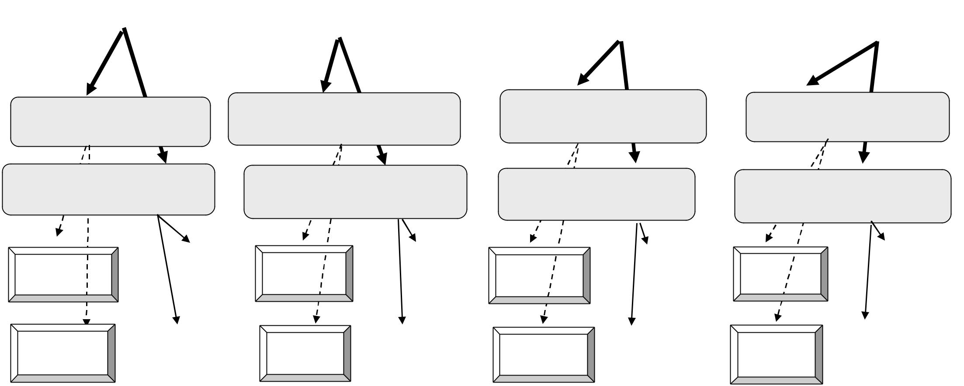

Name: | Name: | Name: | Name:

Name: | Name: | Name: | Name:

 |  |  |  |  |  | Name:
Name: |  | Name: |  | Name: |  | Name: |  | Name: |  | Name: |  | Name: |  | Name:

 |  |  |  |  |  |  | Name:
Name: | Name: | Name: | Name: | Name: | Name: | Name: | Name:

